Jason Carignan
CS 499 – Computer Science Capstone
Professor Satish Penmatsa
February 4, 2026
5-2 Milestone Four: Enhancement Three: Databases
The artifact selected for the Databases category is the Return Merchandise Authorization (RMA) analysis database originally created in DAD 220: Introduction to Structured Databases. The original project used relational tables including Customers, Orders, and RMAs to analyze product returns by state, product, and reason. While the original design supported ad-hoc reporting, it relied on raw transactional data that contained data quality issues and did not scale well for analytics-heavy workloads. For this enhancement, the system was migrated into a new database named QuantigrationRMA_Enhanced, where the schema and data were preserved and then extended to support data integrity, analytics-ready reporting, and performance optimization.
This artifact was selected because it demonstrates how a transactional database can be transformed into a decision-support system. In its original form, the project was limited to one-off SQL queries that could answer individual questions but did not support scalable reporting or analytics workflows. The enhanced version introduces production-grade database practices that are directly applicable to business intelligence, data science, and enterprise analytics.
One major improvement was addressing data quality. Return reasons originally existed as free-text values, which made aggregation unreliable and inconsistent. These were standardized into controlled categories so that reporting would be consistent and analytics-ready.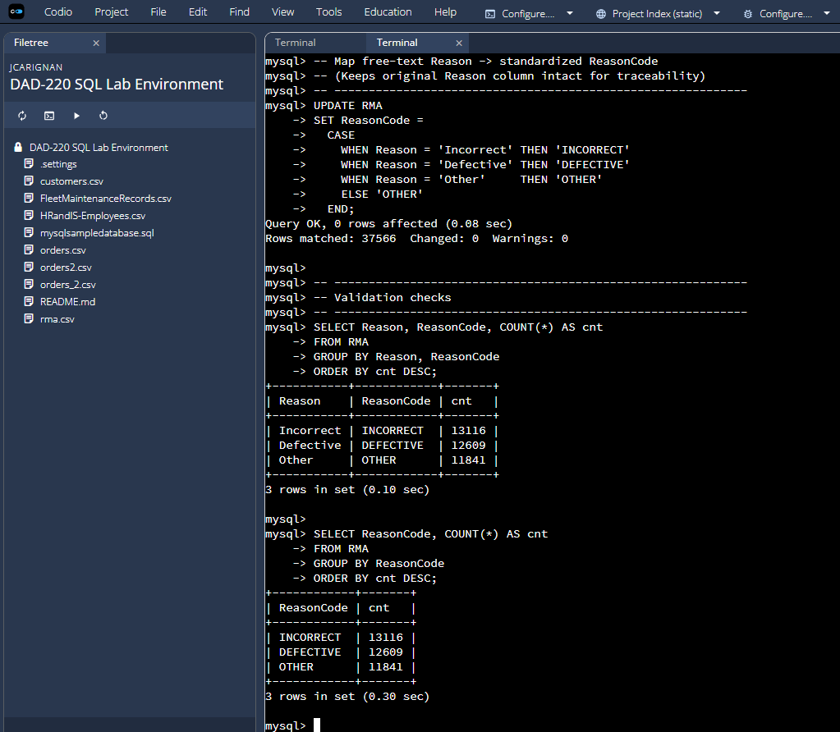
This image demonstrates the standardized return categories and validation logic that ensures consistent classification of return reasons.
Another key enhancement was implementing deduplication logic so that return counts are based on distinct orders rather than raw rows. This prevents inflated return rates when multiple rows exist for the same order, which is a common real-world data quality problem.
The project was also enhanced by creating analytics-ready SQL views that encapsulate complex joins and business logic into reusable reporting layers. Rather than requiring analysts to repeatedly write multi-table joins, these views provide a clean abstraction layer that simplifies reporting.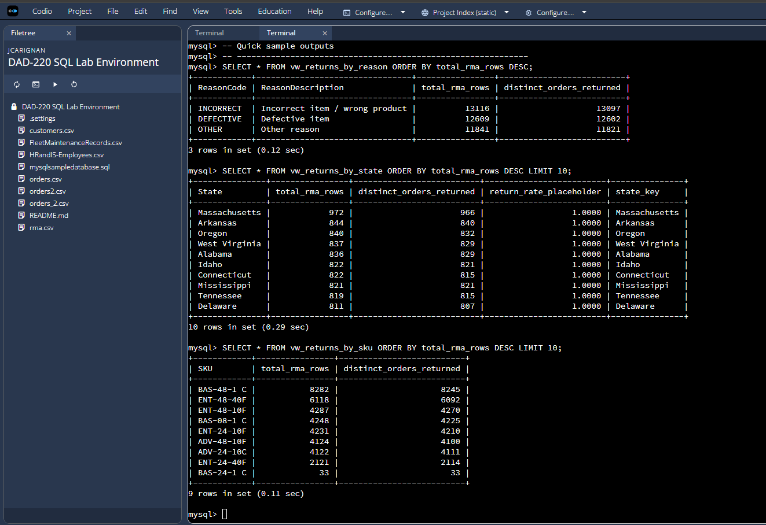
This screenshot shows how business logic is encapsulated within reusable SQL views, supporting dashboard and analytics workflows.
Finally, the database was optimized for performance by adding strategic indexes to support high-volume joins and sorting operations. These indexes were designed to align with common reporting patterns, particularly those involving joins between RMAs, Orders, and Customers and sorting by geographic or product dimensions.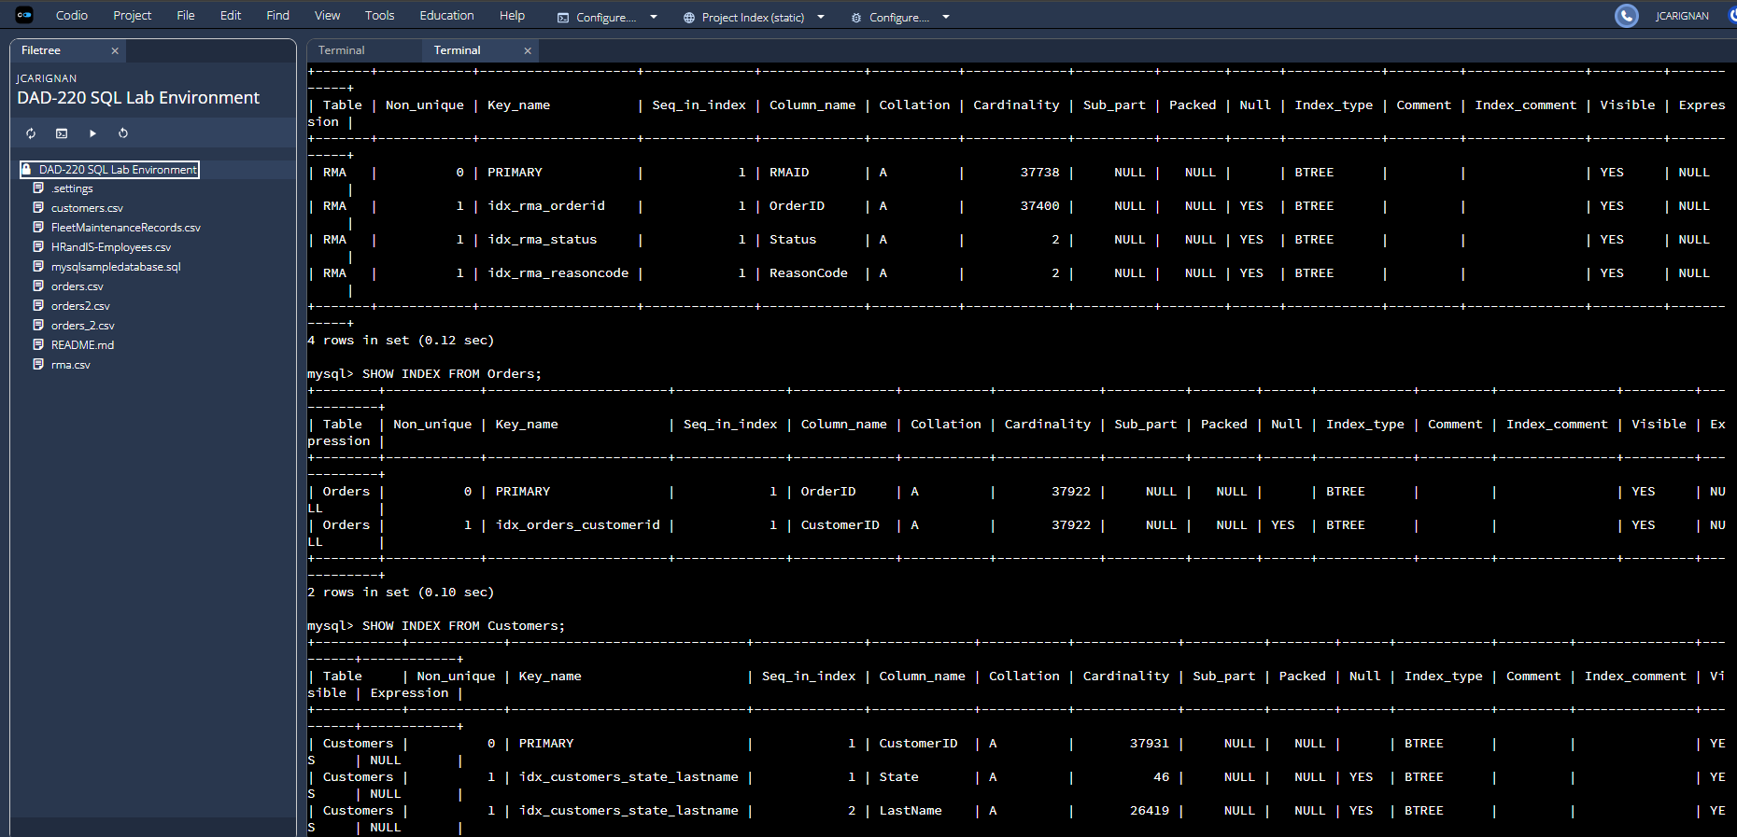
This image illustrates the indexing strategy applied to improve join efficiency and sorting performance.
One of the most important outcomes of this enhancement is the measurable improvement in query performance. To evaluate this, the same analytical query was executed against both the original and enhanced databases using the EXPLAIN ANALYZE function. The query retrieves completed RMAs joined to Orders and Customers and sorts them by customer location, which reflects a common reporting and dashboard use case.
In the original database, the query required a full table scan of the RMA table and a large sort across more than 33,000 rows, resulting in execution times exceeding 400 milliseconds.
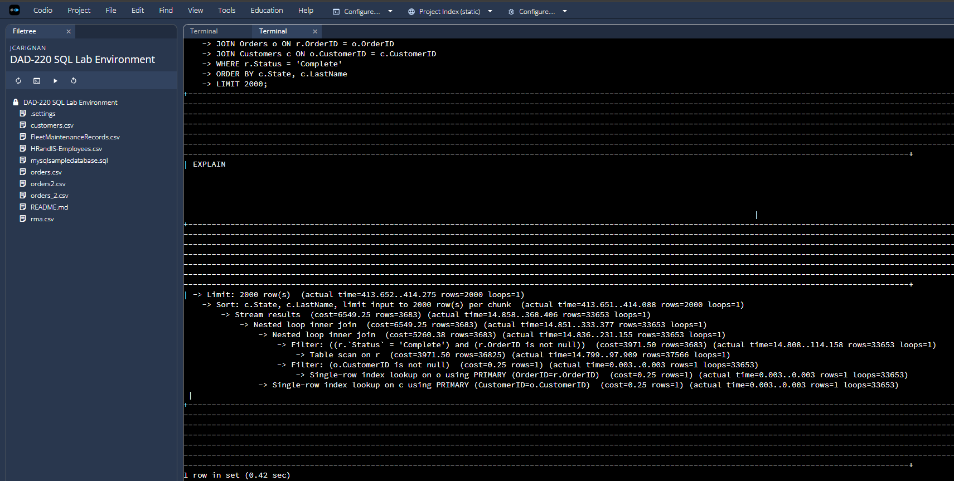
After indexing and query optimization in the enhanced database, the same query uses indexed joins and a covering index to avoid scanning and sorting unnecessary rows. The execution time dropped to approximately 40 milliseconds, nearly ten times faster.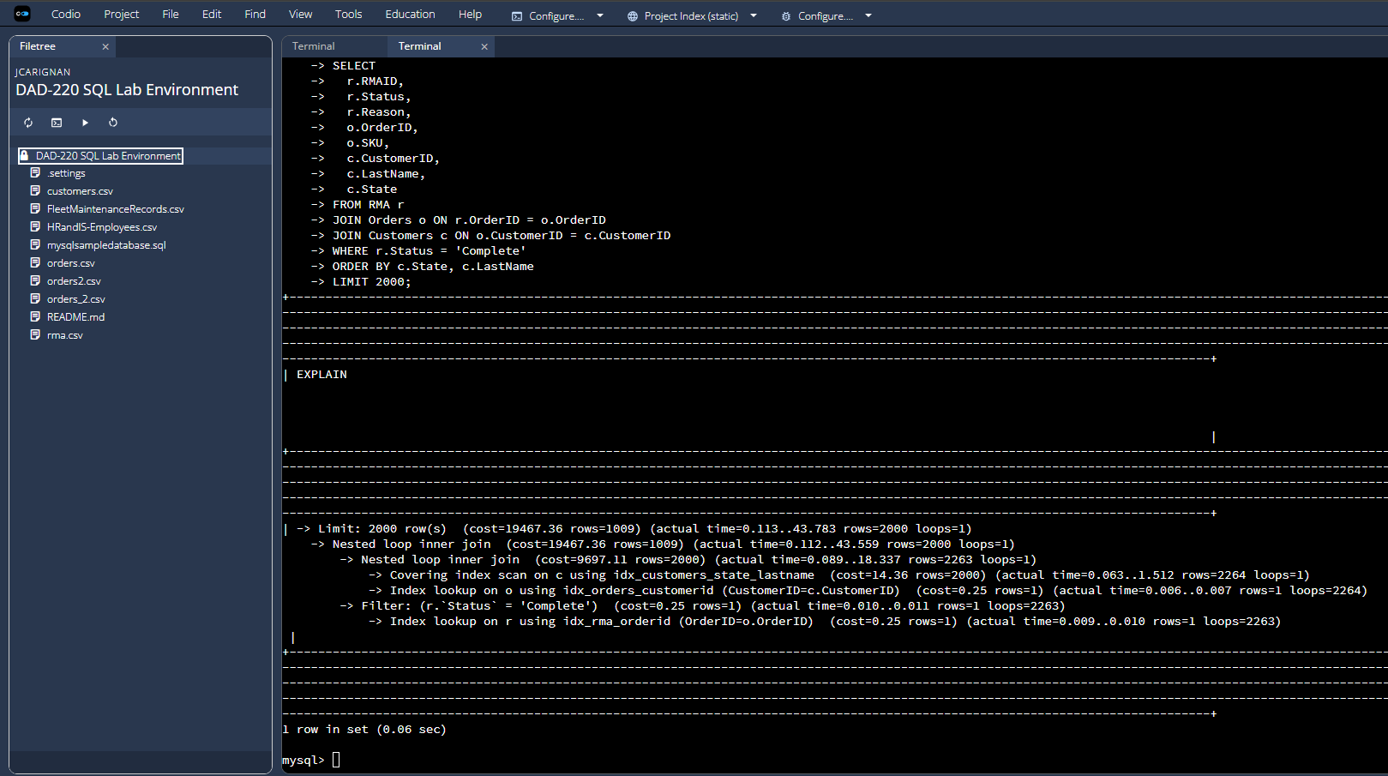
While the improvement is visible at 37,000 rows, the true impact becomes significant at scale. In enterprise systems containing millions or billions of rows, unindexed scans and large sorts can turn dashboards into multi-minute or even multi-hour operations. Proper indexing and query planning allow the system to scale efficiently, enabling near-real-time reporting, interactive dashboards, and data science pipelines that depend on fast data retrieval.
From an end-user perspective, these improvements directly benefit analysts and managers. Cleaner data ensures consistent reporting metrics, preventing conflicting interpretations of return trends. Faster queries enable dashboards to refresh quickly and allow decision makers to explore data interactively without long delays. Instead of waiting for reports to load, stakeholders can focus on identifying patterns, investigating product issues, and making timely business decisions.
These enhancements support multiple Computer Science program outcomes. The use of deduplication logic and reporting views demonstrates Outcome 3, which focuses on designing computing solutions using sound algorithmic and data principles. The use of indexing, optimized joins, and reusable reporting layers supports Outcome 4 by applying well-founded database practices to deliver measurable business value. By structuring the database to serve analysts, developers, and decision makers from the same consistent dataset, the project also supports Outcome 1 related to collaborative decision making.
This enhancement shifted my thinking from writing isolated SQL queries to engineering a scalable data platform. I gained a deeper understanding of how data quality issues, such as duplicate records and inconsistent categorical values, can distort business outcomes if left unresolved. I also developed a stronger appreciation for how indexing strategies and query planning determine whether a database remains responsive as it grows.
The most valuable takeaway was recognizing how relatively small structural improvements, such as controlled vocabularies, distinct-count logic, reusable views, and composite indexes, can produce significant gains in reliability, performance, and scalability. These are foundational principles in professional analytics and data engineering environments, making this artifact a strong representation of my readiness to work with real-world data systems.

